Media Release – Forbes World’s Best Management Consulting Firms

AccountAbility Recognized for a Third Time Among Forbes World's Best Management Consulting Firms 2024
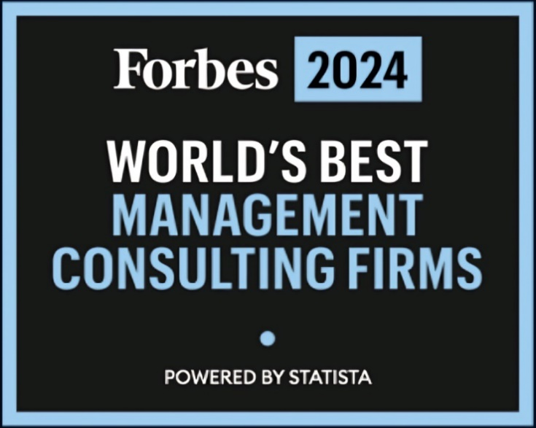

NEW YORK and LONDON, August 13, 2024
AccountAbility, a trusted global ESG Consulting and Standards firm with a three-decade history in guiding leaders to build better companies, is pleased to announce that for the third consecutive year it has been recognized by Forbes as one of The World's Best Management Consulting Firms, this time for 2024.
"AccountAbility is extremely grateful to Forbes, Statista, our clients, and our peers to accept the Forbes award for the third consecutive year. Our continued inclusion in this distinguished ranking reinforces the ever-growing importance of sustainability/ ESG matters and their impact on the global business universe,” said Mr. Sunil (Sunny) A. Misser, CEO of AccountAbility.

"At AccountAbility, we remain committed to delivering practical, effective, and enduring outcomes that enable our clients to succeed. Our journey is shaped by the unwavering trust and invaluable support from our esteemed clients and peers. This recognition further motivates us to remain at the forefront of sustainable business solutions and to advance good ESG practices worldwide,” Mr. Misser added.

To determine The World’s Best Management Consulting Firms 2024 list, Forbes, together with Statista, conducted an independent evaluation of thousands of multinational management consultancies across 13 industries and 14 functional areas. These firms were then evaluated based on survey results conducted among 9,000 consultants (partners and executives of management consulting firms) as well as clients (executives of large global corporations) from different geographical regions worldwide, to identify and recommend The World's Best Management Consulting Firms 2024.

This latest recognition adds to a growing list of multi-year global business awards for AccountAbility, including a three-time winner of the Best ESG Strategy Development Partner from Capital Finance International (2021-23), and a seven-time Leading Management Consultant recipient from the Financial Times (2018-24).

AccountAbility continues its journey towards building better businesses and fostering a culture of integrity, performance, and responsibility in organizations worldwide.

AccountAbility issues an annual global report on the Top Sustainability Trends facing businesses and guides leaders on ESG matters of significant priority for the future; found below:
The 7 Sustainability Trends 2023 Report
About AccountAbility:
AccountAbility is a leading global Consulting and Standards firm that works with businesses, investors, governments, and multilateral organizations to innovate and advance the global Sustainability/ ESG agenda by improving the practices, performance, and impact of organizations. The firm focuses on delivering practical, effective, and enduring results that enable our clients to succeed.
AccountAbility is a Public Benefit Corporation, operating globally through a highly qualified team from offices in New York, London, Riyadh, and Dubai. The firm is the recipient of multiple business awards from the Financial Times, Forbes, and Capital Finance International, and its website is archived with the United States Library of Congress. Learn more at www.accountability.org
Ms. Rachel Rose
AccountAbility
Head of Global Operations
+1 646-507-5905
Email: Rachel.rose@accountability.org
Web: www.accountability.org

